**Voice of Change Initiative (VOCI)© Brand Guidelines**

Contents

**Introduction** 2

**1. Brand Overview** 2

**1.1 Mission** 2

**1.2 Vision** 2

**1.3 Core Values** 2

**2. Visual Identity** 3

**2.1 Logo** 3

**2.2 Colour Palette** 4

**2.3 Typography** 4

**2.4 Imagery** 5

**3. Tone and Voice** 6

**3.1 Brand Voice** 6

**3.2 Writing Style** 6

**4. Applications** 6

**4.1 Digital Media** 6

**4.2 Print Materials** 6

**4.3 Events** 7

**5. Brand Don’ts** 7

**6. Contact Information** 7

## 

## **Introduction**

The Voice of Change Initiative (VOCI) is a transformative movement dedicated to empowering individuals through exceptional communication, authentic personal branding, and principled leadership. Our brand reflects our commitment to integrity, excellence, empowerment, impact, collaboration, and creativity. These guidelines ensure that all visual and verbal representations of VOCI align with our mission, vision, and core values, creating a unified and recognizable identity that inspires change.

These guidelines are designed for all stakeholders—members, partners, and collaborators—to maintain consistency across all platforms, from digital media to print materials, events, and communications.

# **1. Brand Overview**

## **1.1 Mission**

The Voice of Change Initiative is dedicated to empowering students, emerging leaders, and society with the skills, values, and confidence to communicate effectively, build authentic personal brands, and lead with excellence. Through dynamic public speaking programs, transformative mentorship, and meaningful community engagement, we aim to develop a network of change-makers who deliver undeniable impact in every sphere of influence.

## **1.2 Vision**

To empower individuals, especially leaders, with exceptional communication skills, authentic personal branding, and principled leadership skills, enabling them to create meaningful impact across all spheres of life.

## **1.3 Core Values**

* **Integrity**: Upholding honesty and authenticity in all actions.
* **Excellence**: Striving for the highest standards in communication and leadership.
* **Empowerment**: Unlocking individual potential for personal and societal growth.
* **Impact**: Driving measurable and positive change in society and beyond.
* **Collaboration**: Building a supportive and collaborative network of leaders.
* **Creativity**: Equipping individuals with skills to communicate creatively and craft forward-thinking innovations.

# **2. Visual Identity**

## **2.1 Logo**

The VOCI logo is a powerful representation of our mission to harness the spoken word for transformation. It features a stylized profile of a speaking figure with sound waves, symbolizing communication, alongside the acronym "VOCI" and the full name "Voice of Change Initiative."

**Logo Variations**

* **Primary Logo**: The full logo with "VOCI" and "Voice of Change Initiative" text.
* **Icon Only**: The speaking figure with sound waves, used for smaller applications (e.g., social media avatars).
* **Text Only**: "VOCI" with "Voice of Change Initiative" below, for formal documents.

**Logo Usage Guidelines**

* **Clear Space**: Maintain a clear space around the logo equivalent to the height of the "V" in "VOCI" to ensure it stands out.
* **Minimum Size**: The logo should not be smaller than 1 inch in width for print or 100 pixels for digital use to ensure legibility.
* **Do Not**:
  + Stretch, distort, or rotate the logo.
  + Change the colours of the logo outside the approved palette.
  + Place the logo on busy or low-contrast backgrounds.

**Logo Colour Variations**

The logo is available in three colour schemes based on the approved palette:

* **Blue (#1E90FF)**: For digital platforms, youth-focused campaigns, and modern contexts.

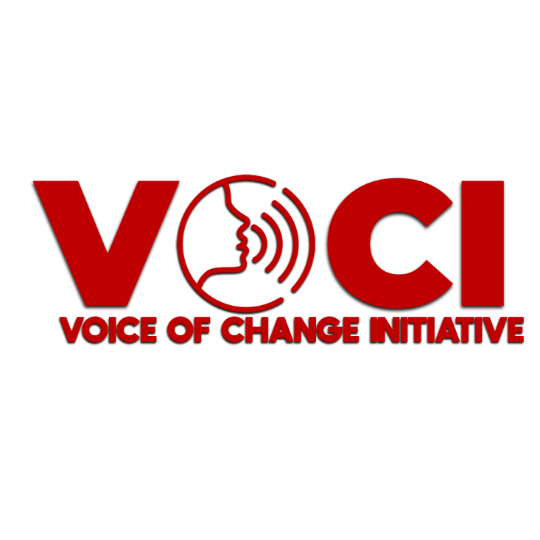

* **Red (#BF0000)**: For high-impact events, print materials, and to convey passion and urgency.
* 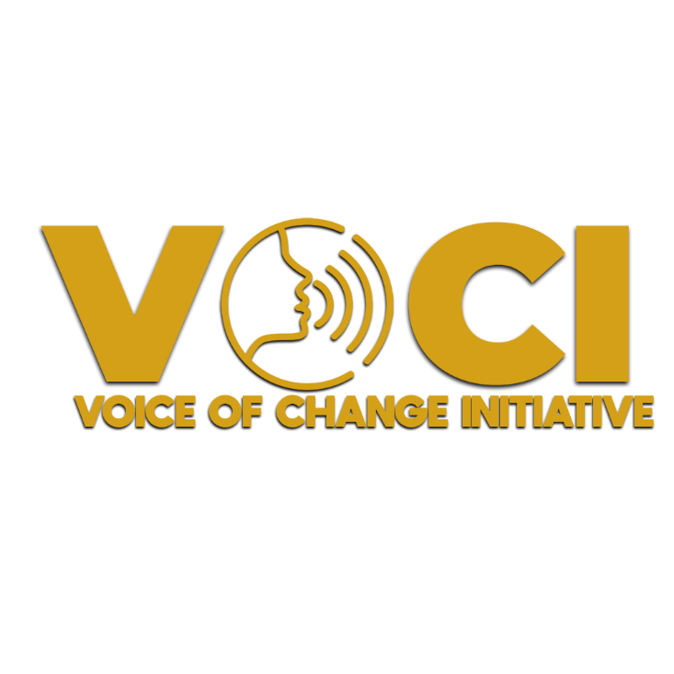**Dark Gold (#D4A017)**: For formal communications, leadership-focused content, and to signify excellence.

## **2.2 Colour Palette**

The VOCI Colour palette reflects our dynamic and transformative identity. The primary Colours are bold and purposeful, while secondary Colours can be used sparingly for accents.

**Primary Colours**

* **Blue (#1E90FF)**: Represents trust, communication, and modernity. Use for digital platforms, backgrounds, and youth-oriented materials.
* **Red (#BF0000)**: Symbolizes passion, urgency, and impact. Use for calls to action, event branding, and high-energy campaigns.
* **Dark Gold (#D4A017)**: Conveys excellence, leadership, and prestige. Use for formal communications, certificates, and leadership-focused content.

**Secondary Colours**

* **Black (#000000)**: For backgrounds, text, and to create contrast.
* **White (#FFFFFF)**: For backgrounds, text, and to ensure clarity.

**Colour Usage Guidelines**

* Use Blue as the dominant Colour for digital and modern contexts (e.g., website, social media).
* Use Red for high-impact elements like event banners, posters, and calls to action.
* Use Dark Gold sparingly to highlight prestige, such as in certificates, formal invitations, or leadership awards.
* Ensure sufficient contrast between text and background for accessibility (e.g., white text on blue or black backgrounds).

# **2.3 Typography**

Typography should be clean, modern, and professional to reflect VOCI’s commitment to clarity and excellence in communication.

**Primary Typeface**

* **Font**: Montserrat
  + **Weights**: Bold (for headings), Regular (for body text)
  + **Usage**: Use Montserrat for all official communications, including digital, print, and presentations. Its modern, geometric style aligns with VOCI’s forward-thinking mission.

**Secondary Typeface**

* **Font**: Open Sans
  + **Weights**: Regular, Italic (for emphasis)
  + **Usage**: Use Open Sans for longer body text, such as reports, blogs, or emails, to ensure readability.

**Typography Guidelines**

* **Headings**: Montserrat Bold, sizes 24pt–48pt (depending on medium).
* **Subheadings**: Montserrat Regular, sizes 16pt–24pt.
* **Body Text**: Open Sans Regular, sizes 12pt–14pt for print, 16px–18px for digital.
* **Line Spacing**: 1.5x the font size for body text to ensure readability.
* **Colour**: Use black or white for body text, with primary Colours (Blue, Red, Dark Gold) for headings or emphasis.

## **2.4 Imagery**

Imagery should reflect VOCI’s mission of empowerment, communication, and leadership.

**Photography**

* Use high-quality images of people speaking, leading, or collaborating in professional or community settings.
* Focus on diversity and inclusion, showcasing individuals from varied backgrounds.
* Avoid overly staged or generic stock photos; prioritize authentic, candid moments.

**Icons and Graphics**

* Use simple, minimalist icons that align with the speaking figure in the logo (e.g., sound waves, microphones, or leadership symbols).
* Icons should be in one of the primary Colours (Blue, Red, or Dark Gold) with a consistent stroke weight.

**Backgrounds**

* Use solid Colour backgrounds in Blue, Red, or Black for high-impact designs.
* For softer designs, use White or a subtle gradient of Blue to White.

# **3. Tone and Voice**

## **3.1 Brand Voice**

VOCI’s voice is **inspirational**, **empowering**, and **authentic**. We speak with purpose and clarity to motivate individuals to unlock their potential and lead with integrity.

**Key Characteristics**

* **Inspirational**: Motivate and uplift with phrases like “Your voice is your power” or “Lead with purpose.”
* **Empowering**: Use action-oriented language, e.g., “Unlock your potential,” “Transform your communication.”
* **Authentic**: Be genuine and relatable, avoiding jargon or overly formal language.
* **Professional**: Maintain a polished tone suitable for leaders and professionals.

**Examples**

* **Do Say**: “Join a movement that empowers you to speak with purpose and lead with impact.”
* **Don’t Say**: “We’re the best at making you a better speaker.” (Too boastful and generic.)

## **3.2 Writing Style**

* Use active voice for clarity and impact (e.g., “VOCI empowers leaders” instead of “Leaders are empowered by VOCI”).
* Keep sentences concise and impactful, especially for calls to action.
* Use inclusive language to reflect VOCI’s commitment to diversity (e.g., “individuals from all backgrounds” instead of “men and women”).

# **4. Applications**

## **4.1 Digital Media**

* **Website**: Use Blue as the primary Colour for the website, with Red for buttons and calls to action. Dark Gold can highlight premium content or leadership resources.
* **Social media**: Create templates for posts using the primary Colour palette. For example:
  + Instagram: Blue background with Red text for event announcements.
  + LinkedIn: Dark Gold accents for leadership tips or professional content.
* **Email Newsletters**: Use Montserrat for headings and Open Sans for body text. Include the logo at the top and a Red call-to-action button.

## **4.2 Print Materials**

* **Posters and Flyers**: Use Red as the dominant Colour for event posters to grab attention, with Blue or Dark Gold accents for details.
* **Certificates**: Use Dark Gold for borders or headings to signify prestige, with Black or White for text.
* **Brochures**: Use a clean White background with Blue headings and Red highlights for key points.

## **4.3 Events**

* **Banners**: Use Red as the primary Colour for event banners, with the logo in White or Dark Gold for contrast.
* **Name Tags**: Use Blue with White text for a professional look, with the logo in the top corner.
* **Presentation Slides**: Use a Black or White background with Blue headings, Red for emphasis, and Dark Gold for key takeaways.

# **5. Brand Don’ts**

To protect the integrity of VOCI’s brand, avoid the following:

* Do not use unapproved Colours outside the specified palette.
* Do not alter the proportions or elements of the logo.
* Do not use fonts other than Montserrat or Open Sans for official communications.
* Do not use imagery that feels inauthentic or misaligned with VOCI’s values (e.g., overly corporate or generic stock photos).
* Do not use a tone that feels overly casual, sarcastic, or unprofessional.

# **6. Contact Information**

For questions about the brand guidelines or to request assets, contact the Digital Media & Communication Head at [insert email] or visit the VOCI website at [insert URL].

**©"Your voice is your power. Use it to inspire, lead, and change the world."**